Software Requirements Specification

Version 1.1

February 11,2018

IShuttle



KODAH.

TABLE OF CONTENT.

Introduction……………………………………………………………3

Scope……………………………………………………………………..4

Functional Requirements……………………………………….5

Prototype……………………………………………………………….7

Non Functional Requirements………………………………..8

INTRODUCTION

This Software Requirements Specification provides a complete description of all the functions and specifications of the iShuttle application designed by the KODAH group.

The expected audience of this document is the lecturer for software engineering third year,Mr Yankey and also the students who will use this system. The document clearly outlines the functions and crux of the app to help the user understand the application better.

Diagrams in this document have been made as clear and simple as possible to be understood by anyone who picks up the document.

This document contains only the description and functionalities of the version one of this app.The document will be updated when a versions two is created.

SCOPE.

The iShuttle app is designed for the students of Kwame Nkrumah University of Science and Technology as well as the shuttle drivers on campus.It enables the student to be able to locate where a particular shuttle is at any point in time,the destination of the shuttle and how long it will take the shuttle to get to where he/she is at that point in time

FUNCTIONAL REQUIREMENTS.

Functional Requirements are those that refer to the functionality of the system, i.e., what services it will provide to the user.

STUDENT.

Map Interface

Splash Page

|  |  |
| --- | --- |
| ACTIVITY | DESCRIPTION |
| Splash Page | It is used to indicate our brand to the students whiles some background processes load |
| Map Interface | It displays the map with driver location and bus destination |
| Log In | The driver enters his user name and password on this page and if it matches the one that is already in the database the log in is successful |
| Online Database Server | The online server stores the drivers details and frequently updates on the location of the driver.A secret code for drivers is hard coded in the database |
| Sign Up | Drivers do their initial registration with user name password and a secret code |

DRIVERS

Online Server Database

Map Interface

Log In

Splash Page

Sign Up

PROTOTYPE

SPLASH PAGE.

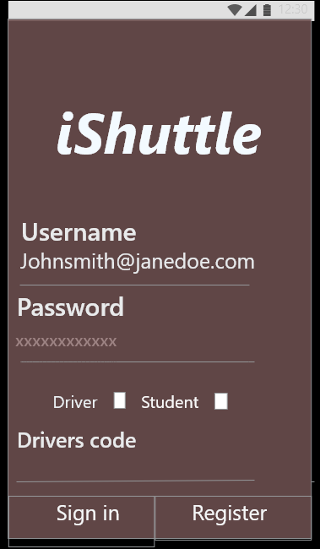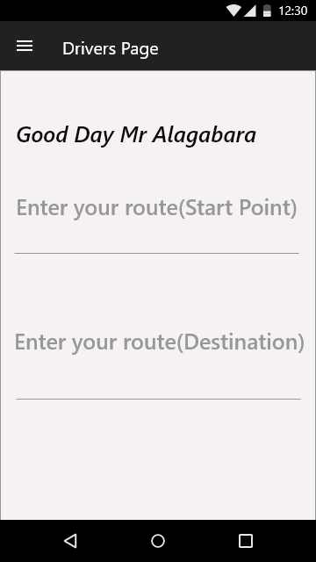

NON FUNCTIONAL REQUIREMENT.